**SPH3U 13.5 Transformers**

1. **How transformers work**

|  |  |
| --- | --- |
| Transformer: |  |
| AC |  |
| how it works |  |

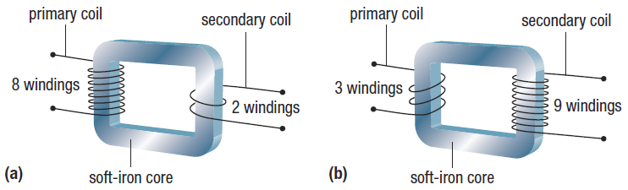

|  |  |
| --- | --- |
| Step-down transformer: |  |
| Step-up transformer: |  |
| Conservation of energy: |  |
| Equations: |  |

A step-down transformer used in an adapter for a laptop has a primary voltage of 120 V. There are 250 windings in the primary coil and 25 windings in the secondary coil. Calculate the voltage in the secondary coil.

A step-down transformer used in the adapter for a cellphone charger has a primary voltage of 120 V and a secondary voltage of 5.0 V. The current in the primary coil is 0.10 A. Calculate the current in the secondary coil.

**Homework:** page 609: #2, 7-9